Cosmetic Dentistry

Veneers
What are veneers?
Veneers are restorations made of a thin ceramic material which is placed over a tooth. Veneers can be used to improve your smile or change it to the smile you always wish you had.
Veneers come in two forms. Porcelain veneers which are like thin translucent shells or composite resin veneers, where layers of resin are built up on your tooth.
We offer both porcelain veneers and composite veneers, each have their benefits; however, porcelain veneers are considered the superior product, providing excellent longevity, strength and exceptional aesthetic results. Naturally they are also the more expensive option.
Alternatively composite veneers can also provide an excellent, natural looking aesthetic result. However, with time they can start to lose their lustre and shine.

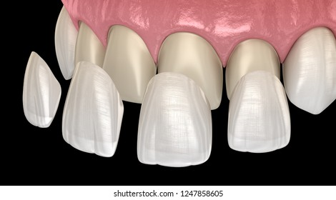

Crowns
What are crowns?
Crowns are caps that fully covers your tooth. A crown completely encases the visible part of your tooth which sits above the gum and allows you to keep a badly broken down or unsightly tooth. Crowns can be made of all ceramic, porcelain fused to metal, or gold. Each material has its advantage and specific reason for use.

Types of Crowns
- All ceramic: Used for both front and back teeth, are extremely aesthetic
- Porcelain fused to metal: Generally, just used in the back of the mouth now. Have been around for decades.
- All gold: Generally, only used for rear teeth. They are really strong and require less tooth to be removed, ideal for people who grind their teeth.

Bridges
A bridge can be used to replace one or more missing teeth. It requires with the use of teeth on either side of the gap to be prepared for crowns, then the final prosthesis is cemented into place and replaces the missing tooth/teeth. Bridges are less commonly used now days, and generally are only used when a dental implant is not suitable or possible.

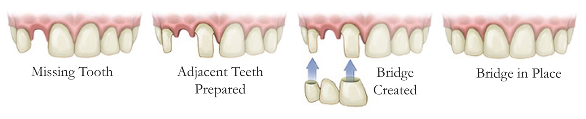

Teeth Whitening
Professional at home whitening kits.
We use Philips Zoom whitening kits, which are a professional strength whitening system. It comes in a range of strengths to suit your individual needs. A course of whitening generally takes between 1-3 weeks. While whitening your teeth, it is common for them to become sensitive, this will resolve once whitening is completed.

